Critical Communication, There’s No App For That
LaTosha D Phillips
King University

Critical Communication, There’s No App For That
Didactic Teaching Strategy Lesson Plan
Critical communication comes in different types when new graduate nurses begin their career. There are three very important communication relationships between nurses. First is the communication between the nurse and the patient and family. Second is the communication between the nurse and the physician. Last but maybe the most important, comes the communication between nurse to nurse in handoff and report. These three relationships are crucial to patient safety.
Class Content Focus
These three relationships may seem a no brainer, but there are app’s for many things these days. There are app’s for ordering your coffee before you drive up to Starbucks, there are app’s to watch your puppy or child from home, you can keep any eye on your credit score, and record all things typed on your child’s phone. But, there isn’t an app to help you with critical communication between the three above mentioned relationships. One would think it’s just talking, but this lesson plan will give you resources to have better communication skills and active participation in these roles. The lecture will start with communication styles, body language, and tools to use to keep your interactions organized and respectful. Tools such as SBAR and IPASS help when giving report to another nurse or to a physician. Resources such as talking with Heart-Head-Heart will help new nurses understand what family centered care is all about. SBAR, stands for situation, background, assessment and recommendation. A copy of each tool is in the appendix. The video for Heart-Head-Heart communication is about four minutes in length. Printing off a copy of the tools for the participants would help give them something to take notes on and a hard copy to keep.
QSEN Competency
The QSEN competency that this communication lecture will meet is the competency of teamwork and collaboration. The very words teamwork and collaboration are the ground roots of critical communication and is how we keep our patients safe.
Learning Domain
This lecture and role play activity is geared towards the affective domain of learning. Just as Billings and Hallstead (2016) describe “the affective domain of learning encompasses attitudes, beliefs, values, feelings, and emotions” (pg. 168). This may be a difficult domain to discuss, but being transparent in our education will help bridge the reality gap of new graduate nurses into their role as a new nurse.
Critical Communication Activity
Three scenarios will be provided to six students. Each will take a folded piece of paper that describes their role in the communication exercise and pointers on how to react. First, we will start with two nurses who are giving a hurried and rushed report. One nurse will ask appropriate clarifying questions while the other nurse seems rushed, uninterested, and gives a really poor handoff. Immediately after the role play, ask the class what went well and what went poorly. The nurses will then return and role play a respectful, complete handoff including bedside report. The second scenario will be between a nurse and family member. The scenario will explain for the nurse to have poor body language and not pay much attention to the family member. The participant playing the family member should become very agitated and verbally aggressive due to the behavior the nurse has shown. Immediately after this interaction ask the class for what went well and what made this interaction go south quickly. The two participants get a second chance to have a healthy and positive nurse to patient family interaction. Followed by a quick debrief on how this felt to each of them. If you are not pressed for time, ask for real life examples from the class on how this has happened in their career thus far. The third set of participants will be a nurse and physician interaction. The nurse is to be unorganized and fumbling with a report and the physician is to be demeaning and argumentative with responses. Immediately following the interaction ask the class how they feel that went. The second scenario will have the nurse prepared and organized with their thoughts, the physician will be respectful and calm in their demeanor. Immediately ask the class for feedback. How did everyone do? Has anyone been in those shoes before?
Key Concepts Learned
Participants will discuss what critical communication consists of. Participants will revise and change behavior to support critical communication as it relates to patient safety.
Resources Needed
A classroom setting is needed to present the short lecture. The ability for the participants of the role play will need to step out of the class with the instructor to discuss the scenarios and any questions they may have. If you feel the need for any small props like a chart, computer, or phone could be helpful, but they are not necessary. The three scenarios can be very descriptive or give the participants a chance to use their imagination.
Amount of Time and Debriefing
This lecture and role play with any sort of discussion can easily be forty-five minutes to an hour. If there aren’t many participants and not a lot of discussion back and forth it may be closer to thirty minutes. The short lecture should be about fifteen minutes. Then ten minutes for each scenario and a quick debrief. This may be a lecture you use at the end of the day to engage the participants in good discussion back and forth.

Reference

Billings, D. M., & Hallstead, J. A. (2016). Teaching in Nursing A Guide for Faculty. St. Louis: Elsevier.

Appendix A
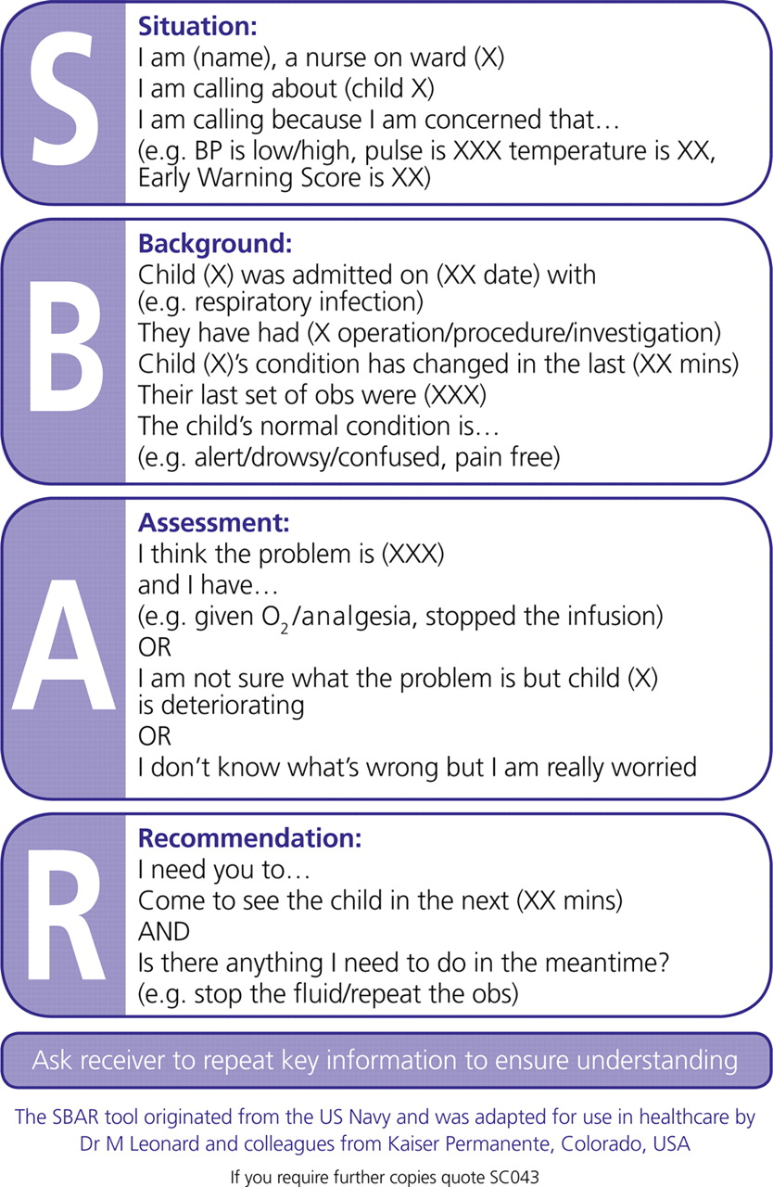
Appendix B
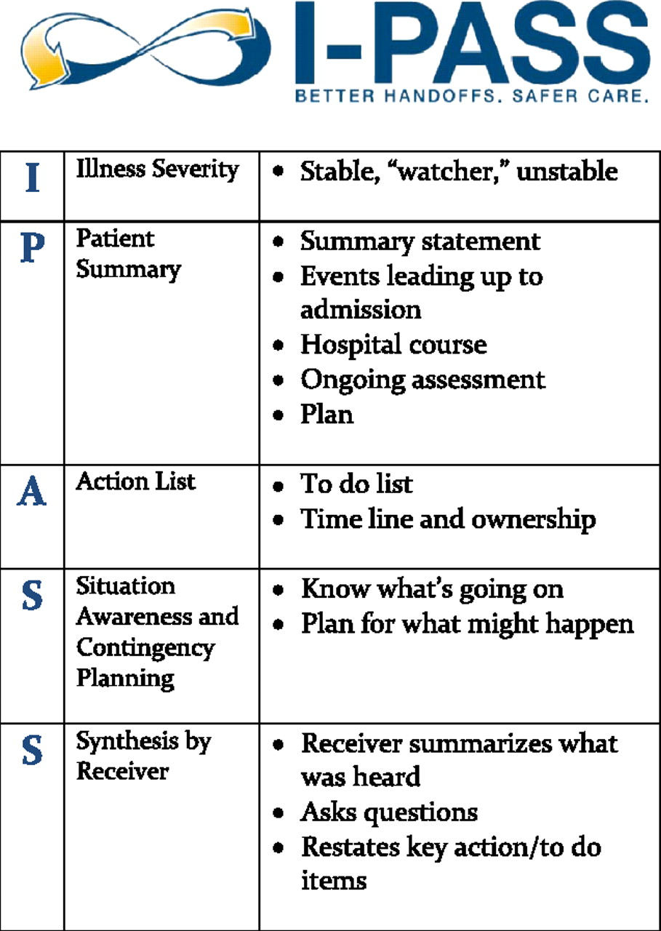
Appendix C
https://youtu.be/RqvPzGowVGk
Play video for the class.

